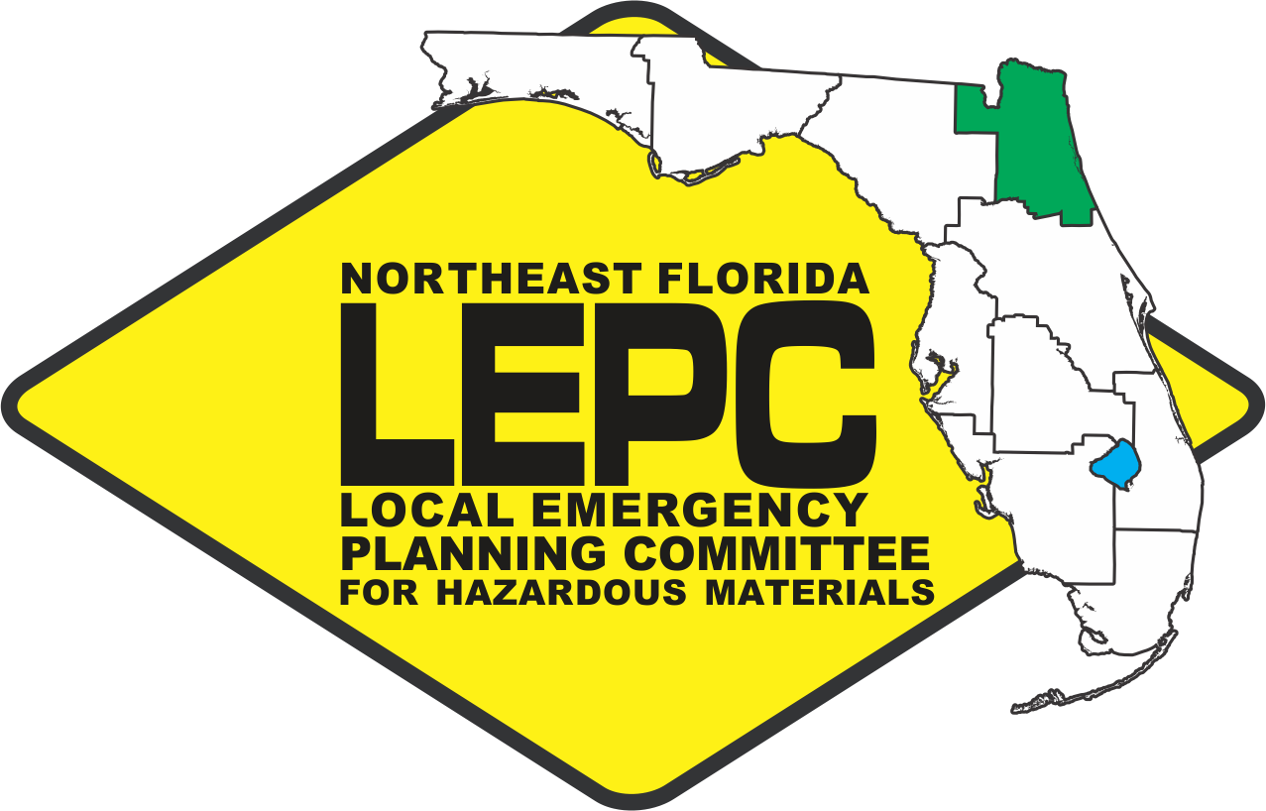 | Northeast Florida LEPC  Hybrid Meeting  40 E. Adams Street,  Jacksonville, FL 32202  https://nefrc-org.zoom.us/j/88017275062  Meeting ID: 880 1727 5062  Wednesday, May 14th, 2025  10:00a.m.

Agenda

- Call to Order

- Roll Call & Introductions

- Review Draft Minutes*
  - February 12th, 2025

- Welcome Membership
  - New Member: Chris Seymour
  - New Member: Joe Durden

- State Emergency Response Commission (SERC) Meetings
- April 13 & 14

- Current Business/Reports
  - Member Updates
  - CSX After-Action Report
  - Regional LNG Training (Fall 2025)
  - End of LEPC Fiscal Year

- Sub-Committee Reports
  - Training Report
    - SJC HazMat 160

- Public Comments

- Adjournment* *Denotes Action

